Suzanne Hanna Memorial
Community Garden

Corner of Placid and Palace Drive
Longing to garden? Craving fresh vegetables?
Missing getting your hands in the dirt?
Yearning to learn how to grow food?

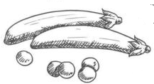

A community garden is gardened
collectively by a group of members.

Enjoy physical exercise and well-being in the outdoors.
Grow healthy food and promote food security.
Gain new skills, meet people and achieve common goals.
Share knowledge and learn from others.



Apply to get on our waiting list for the next growing season!
Please email SHMCommGarden@gmail.com with your name, phone and email.

- Beds are assigned on a first-come first-served basis in the spring.
- Each bed is 10’ x 4’ (40 square feet).
- The rental fee of $25 per bed is payable when a bed becomes available.
Member responsibilities include volunteering for garden operations and work bees, communication and cooperation, as well as planting, maintaining and harvesting your garden bed.



