

Sault Ste Marie

Horticultural Society

November News!
  - October/November 2025 Issue

Fall is finally upon us!! It has been a great year for gardeners and hopefully, you have had a very successful year.



Annual Christmas Turkey Dinner

This event is to be held on December 1st at the Grand Gardens North, same venue as last year.
Tickets will be available at the November 3rd general meeting or you can contact Wendy Bingham and Cleo Walker to purchase if you cannot attend the meeting in person.
Wendy’s Info: 708 North St. Email: binghamwa@yahoo.ca Phone: 705-942-0338
Cleo’s Info: 101-334 Dacey Rd. Email: ssmhortsecretary@gmail.com Phone: 705-989-2335
There will be a delicious turkey dinner prepared by the Grand Gardens staff!!
So put the date on your calendar and get your tickets early for this festive occasion!!!!
**November 26th is the deadline for ticket purchases as the Grand Gardens needs confirmed numbers for dinner**
So please get your tickets soon!

Bulb Fundraiser from the OHA
We have purchased bulbs from the OHA for a fundraiser! If you want to purchase these bulbs for planting, they will be available at the November meeting.
Price of the bulbs are: $35 for 50 bulbs!
So let’s particiate in a great fundraiser and get some extra special bulbs!
“Flowers are a restful thing to look at! They have neither emotions nor conflict”.

2026 Calendars
There was a photo contest conducted in order to create a calendar made up of all the district 13’s “best of the best” photos from 2025.
These pictures will represent society each month and information about meeting times, special dates, etc.
So, let’s make this a great event and ‘hopefully’ it will happen each year to help introduce our societies to others who might enjoy “Getting their hands dirty with us!
Price for the calendars is $25 per calendar. More Information to follow.


Message from Kelly at the OHA Headquarters!
It’s time for our December 50/50 draw, to be held on December 13, 2025. As always, proceeds will go to support Garden Grants and Education in Ontario.
Get your tickets now at
https://www.rafflebox.ca/raffle/ontario-ha

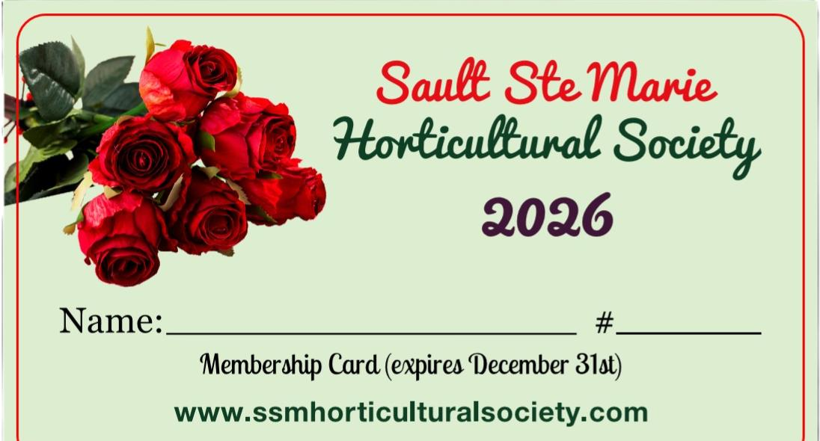
2026 Memberships!!
Are now available: price is $15/member!
Makes a ‘perfect’ Christmas gift for someone you know who may be interested in joining our Society!!
With your membership, you get to enjoy discounts at designated Garden Centers in our city!
November Guest Speaker is:
Margaret Carruthers
on
“Raised Garden Beds”

Election of SSM HS Board will take place at the November meeting!!
So, if you know of someone to nominate maybe yourself or a friend, we are looking for you!

Recipe of the Month
Bubbly Bacon & Butternut Dip
By
Jennifer Bartoli and the Canadian Test Kitchen
Grating squash take a bit of effort but allows it to cook faster, saving time.
Dip is piping not when it comes out of the oven, so let it cool before serving

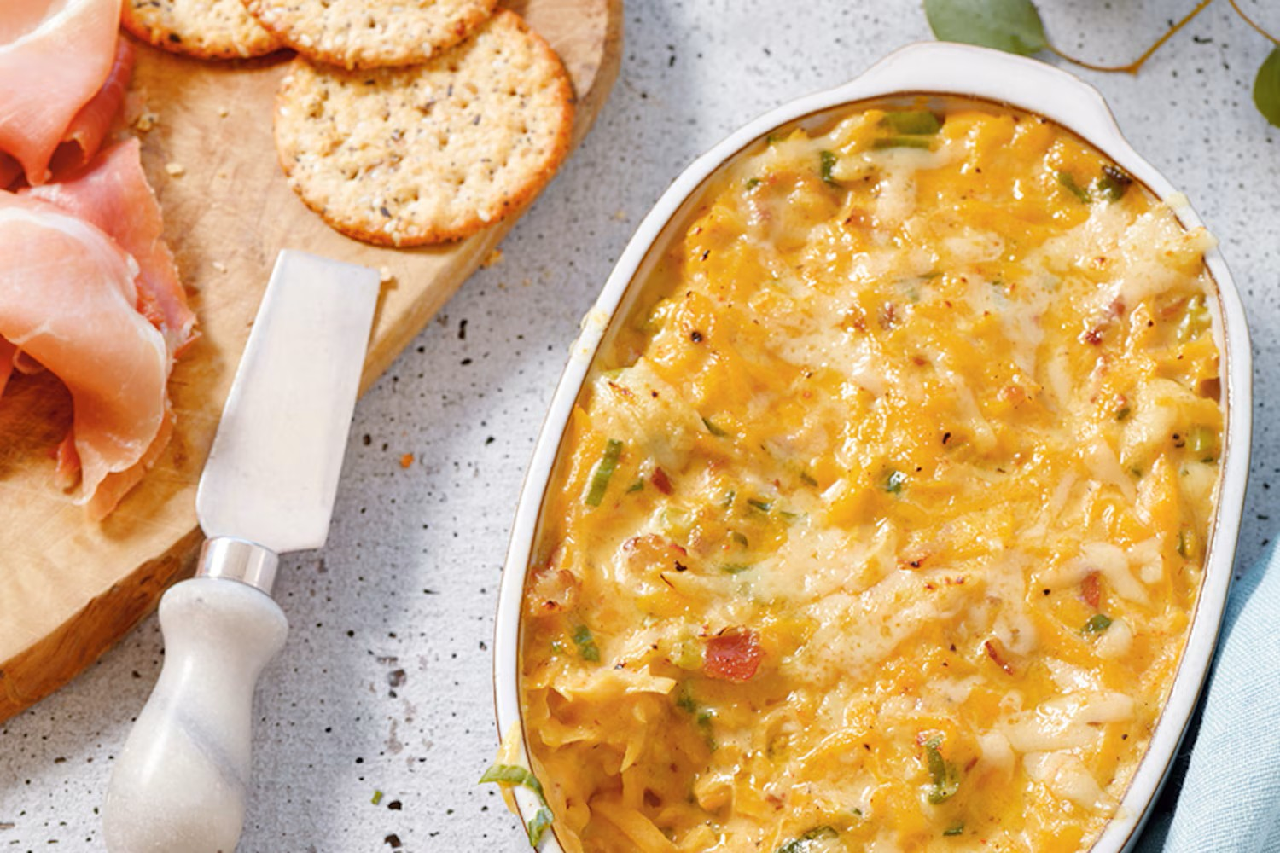
Hands on time: 30 minutes
Total time: 40 minutes
Makes: about 2 cups
Ingredients:
• 4 strips bacon thinly slicked
• 2 cups grated seeded peeled butternut squash
• 3 green onions thinly sliced
• 3 cloves garlic minced
• 2 tablespoons butter
• 2 tablespoons all-purpose flour
• 2/3 cups milk
• ½ cut shipping cream (35%)
• ¼ teaspoon pepper
• Pinch of salt and cayenne pepper
• ¾ cups shredded Gruyere cheese
• 2 tablespoons lemon juice

Method:
In saucepan, cook bacon over medium heat, stirring occasionally, until lightly browned, about 5 min. Use slotted spoon & remove bacon to a bowl.
Reserving 2 tsp. fat, drain. Return reserved fat to pan & add squash – cook over medium heat stirring & adding 2 tbsp water when squash starts to stick. Cook until soft about 5 min. Add green onions & garlic, cook, stirring until fragrant about 1 min. Remove from heat & stir in bacon. Put into bowl & set aside.
In same saucepan, melt butter over med heat & add flour – cook whisking constantly for 1 min. Whisk in milk, cream, pepper, salt & cayenne pepper – bring to a boil. Whisk often. Reduce heat & simmer, whisking until thick enough to coat back of a spoon – about 4 min. Stir in squash mix, ½ cups of Gruyere. Boil for 4 min. Let stand for 5 min.
NUTRITIONAL FACTS: Per tbsp: about 48 cal. 2g pro, 4g total fat (2g sat. fat), 2g carb (trace dietary fiber), trace sugar, 12mg chol, 56mg sodium, 47 mg potassium. % RDI: 4% calcium, 1% iron, 10% vit A, 2% vit C, 1% folate

If you have a favorite recipe, please send it on to: ssmhortsecretary@gmail.com

